Run the command:

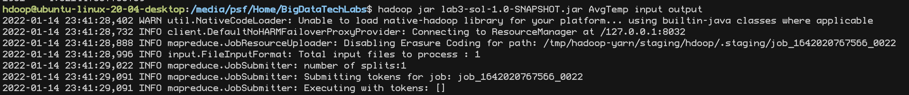

The results:

